January 2020
Schoology Installation Guide - Instructors

If you have a free Schoology account, talk to your librarian or media specialist to find out which Gale products you have access to. Then find each Gale product app you want to install in the Schoology App Center.

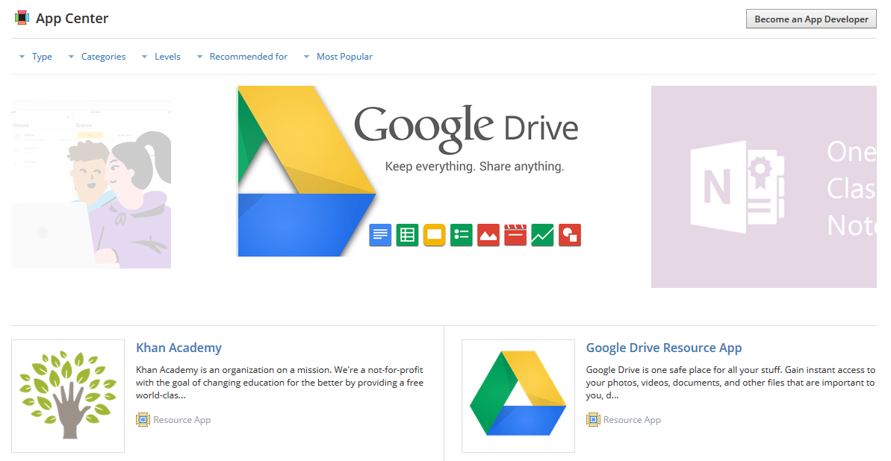
Click the app to view details, then click Install LTI App.
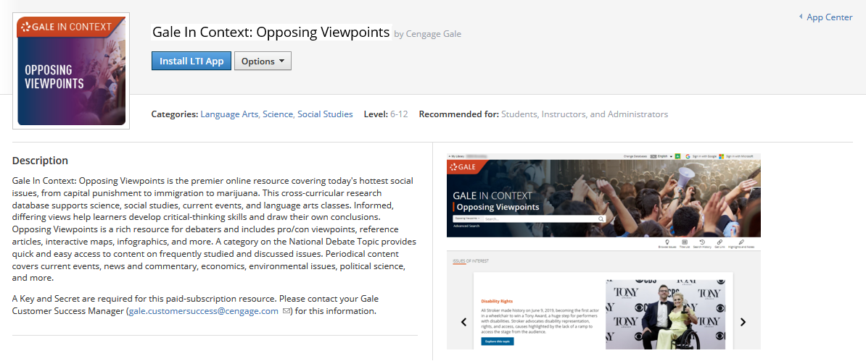

Before you can use the App, you’ll need to configure each one with a Consumer Key and Shared Secret. Contact your Librarian or Media Specialist, and they’ll need to contact their Gale Customer Success Manager for this information.

Go to the Course where you’ve installed the App and click Edit Privacy/Course Settings under Course Options.

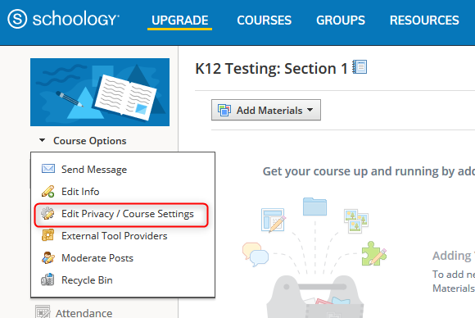

Within Settings, click to the External Tools tab.

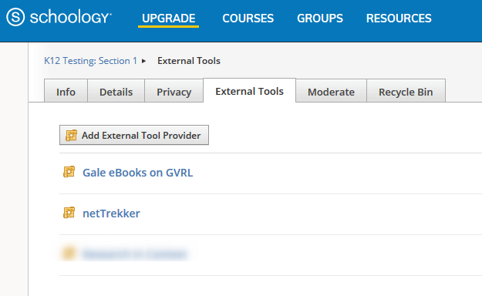

Click on the App you want to configure, then enter the Consumer Key and Shared Secret when prompted. (Custom Parameters are not needed.) Click Submit and the App is ready to use in your Course! It will appear in the left navigation and in the rich text editor to add content to Assignments, Discussions, and more.

