December 2021
Schoology Installation Guide - Admins
For each Gale product App you want to install, find the product App in the Schoology App Center. For a list of Gale products available through Schoology, see the document LTI Install URLs at https://support.gale.com/technical/lms. Check with your Librarian or Media Specialist to find out which Gale products your district or school has access to.

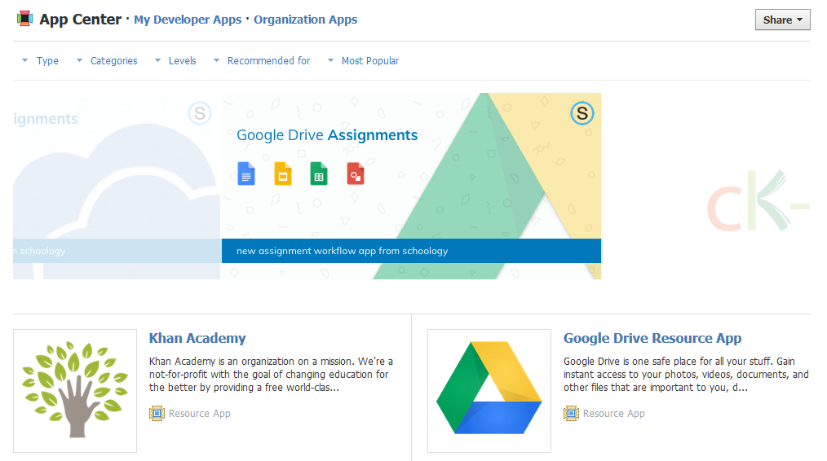

Click the app to view details, then click Install LTI App and choose Add to Organization.
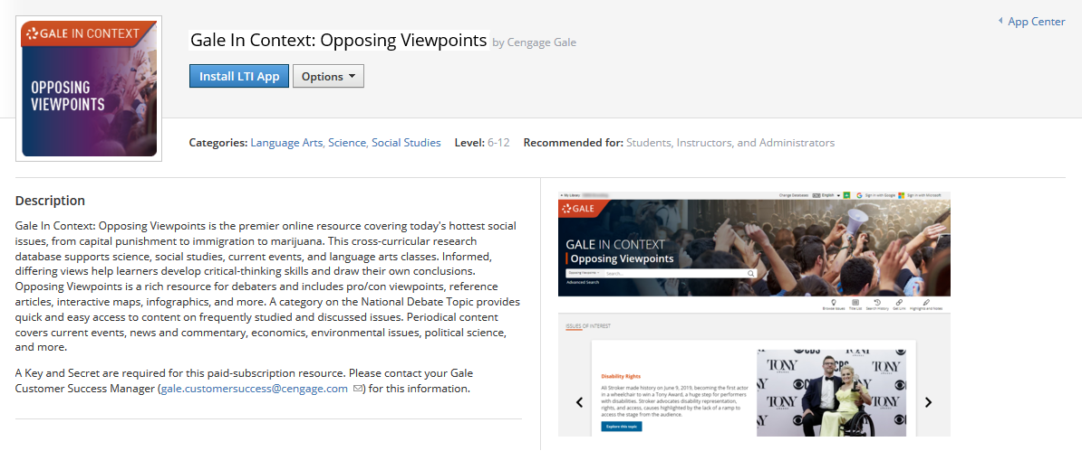

*To add the app to all schools/buildings:
Under Organization Apps, select Configure for the newly added app
- Consumer Key: Gale location id (contact your Gale Customer Success Manager if you don't know yours)
- Shared Secret: Secret from Gale Admin (contact your Gale Customer Success Manager to generate for you)
- Custom parameters: (not needed)
- Click Save Settings

On the same page, select Install/Remove to indicate where you’d like to install the app for Users, Courses, and/or Groups, and click Submit.

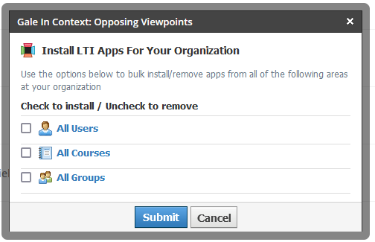

Instructors will see the app in their courses, or wherever you install the app for them.

*If you want to install apps to particular schools/buildings, and/or use a different Consumer Key/Shared Secret for each, ask your Gale Customer Success Manager for the Keys/Secrets for each building/school. Then find additional information at this link to Schoology’s Help Center and reach out to your Schoology Client Success contact to help with the install.

