June 2020
Moodle Installation Guide
*Note: Do not add Gale Apps/Products as a preconfigured tool, as each resource depends on its own custom parameters for functionality.
You’ll need to install each App/Product separately, changing the name and custom parameters for installation.

Within a course, install Gale Apps as External Tools, using the instructions below:
- Click the gear in the upper right-hand corner and choose the Turn Editing On option
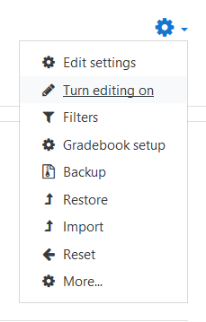
- Click the Add an activity or resource link
- Choose the External Tool option under ACTIVITIES and click the Add button
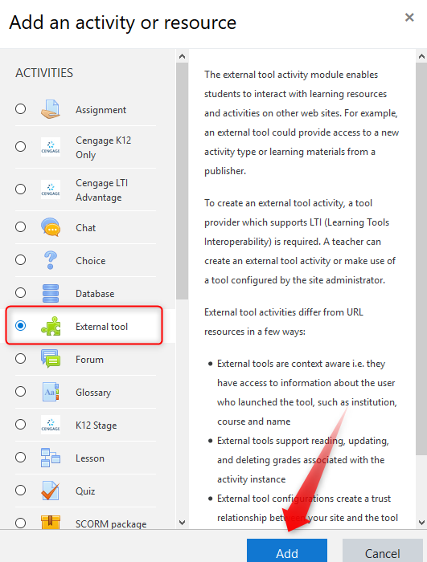

External Tool details:
- Add activity name: Enter a name (e.g. Gale In Context: Opposing Viewpoints In Context, GVRL eBooks, Gale Primary Sources)
- Preconfigured Tool: choose Automatic, based on tool URL
- Tool URL: https://link.gale.com/apps/launch
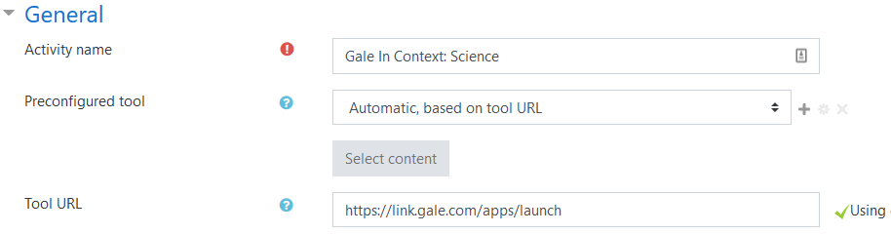

- Click Show more...
- Launch Container: choose Embed
- Consumer Key: Gale location ID (contact your Gale Customer Success Manager if you don't know yours)
- Shared Secret: Enter the Secret from Gale Admin into the Shared Secret field (contact your Gale Customer Success Manager to generate for you)
- Custom Parameters: Change the product to match the product you're installing (see LTI Install URLs document for custom parameters by product at http://support.gale.com/technical/lms)
action=create activity
product=SCIC
lms_name=moodle

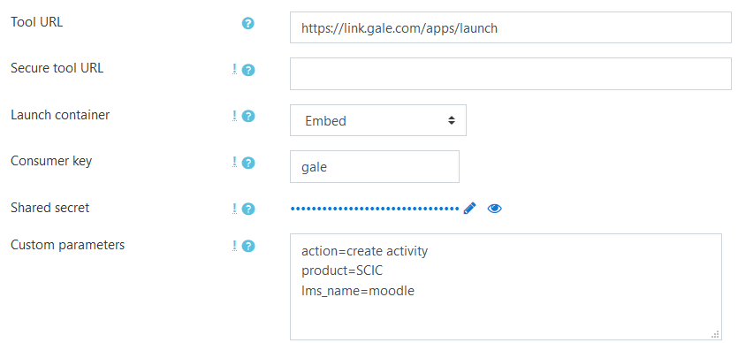

- Click Save and access the resource in your course

