January 2020
D2L/Brightspace Installation Guide
From Course Admin, Select External Learning Tools

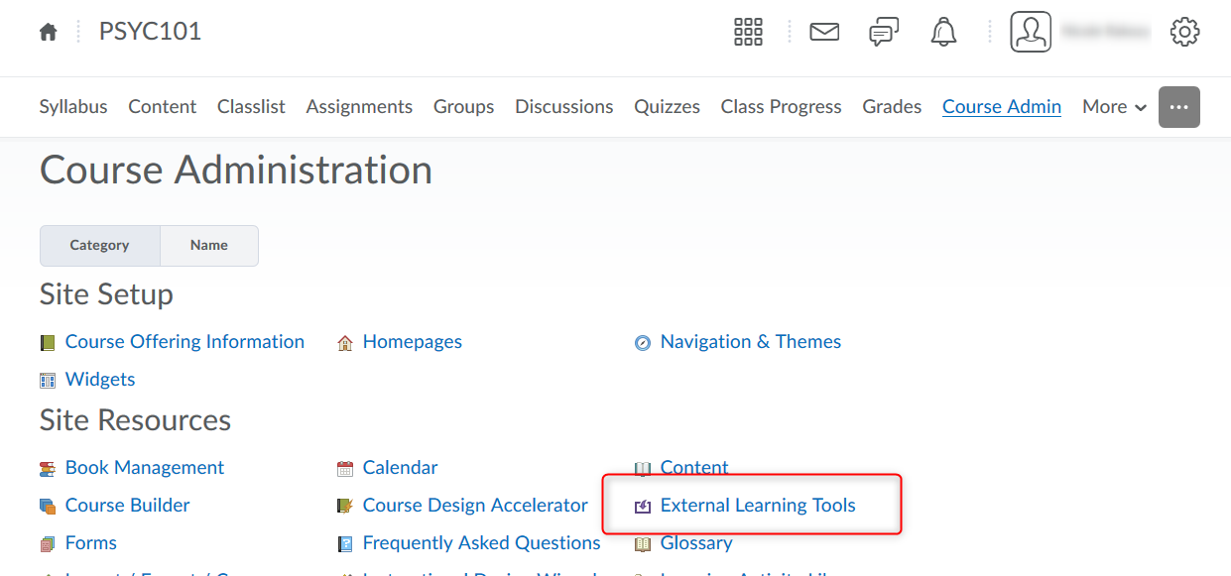

Click to Manage External Learning Tool Links
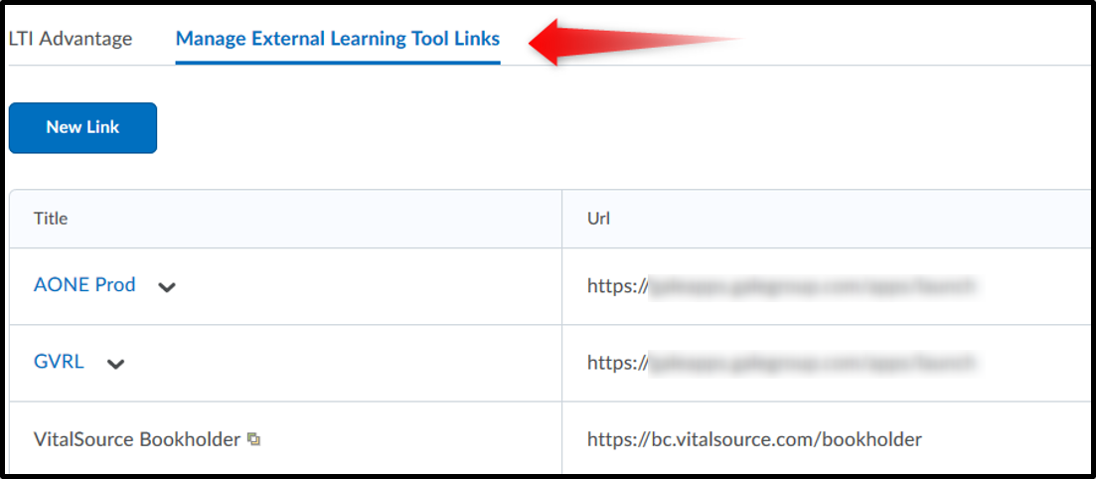

Then click on New Link

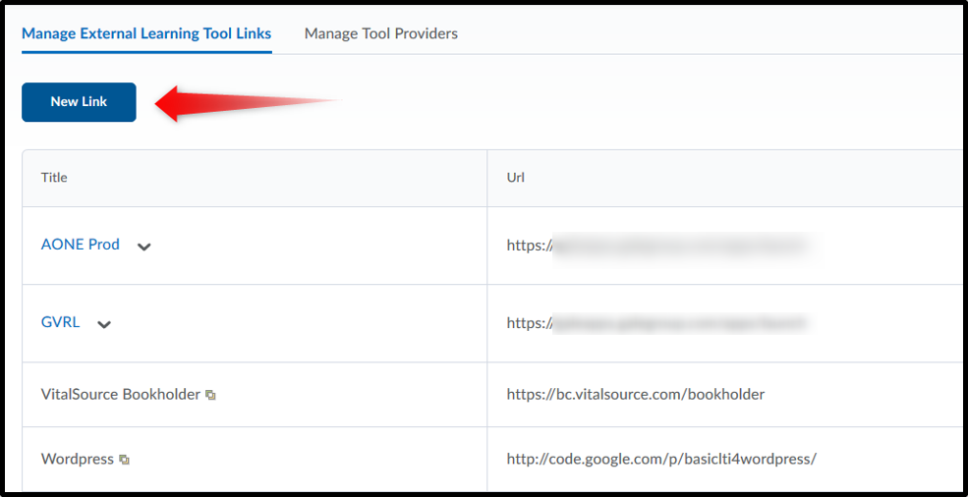

Enter Properties for the Link you’re adding.

- Title: Name of Gale app (e.g. Gale In Context: World History)
- URL: https://link.gale.com/apps/launch (for any/all Gale products)
- Add Description if desired
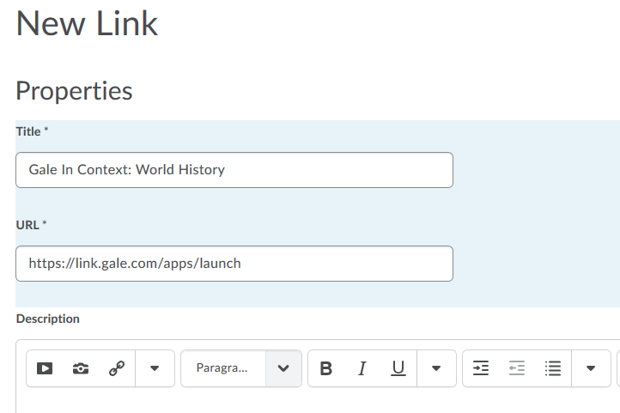

- Under Key/Secret, select “Link key/secret”
- Then enter the Key and Secret from your Gale Customer Success Manager
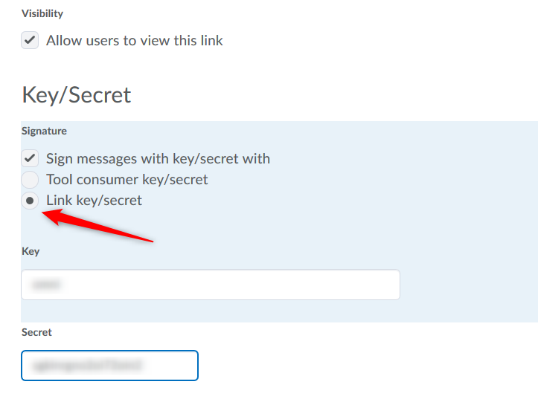

- Place the number “2” in the Add custom parameters row, and click on “Add custom parameters”
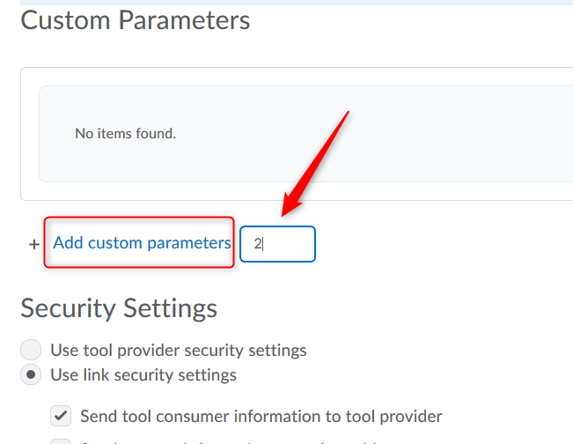

- Click “Save” if presented with this window.
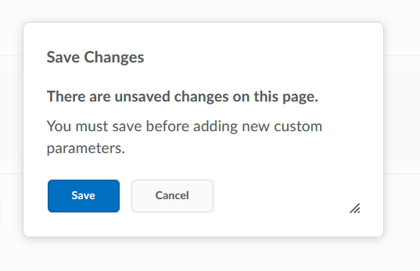

The top of the page has now changed to Edit Link and the Title you provided.

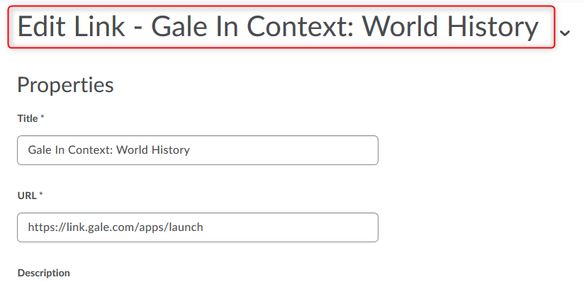

Now scroll down to the Custom Parameters rows you just added and add the information for the product and LMS (this information can be found in the LTI Install URLs document at https://support.gale.com/technical/lms)
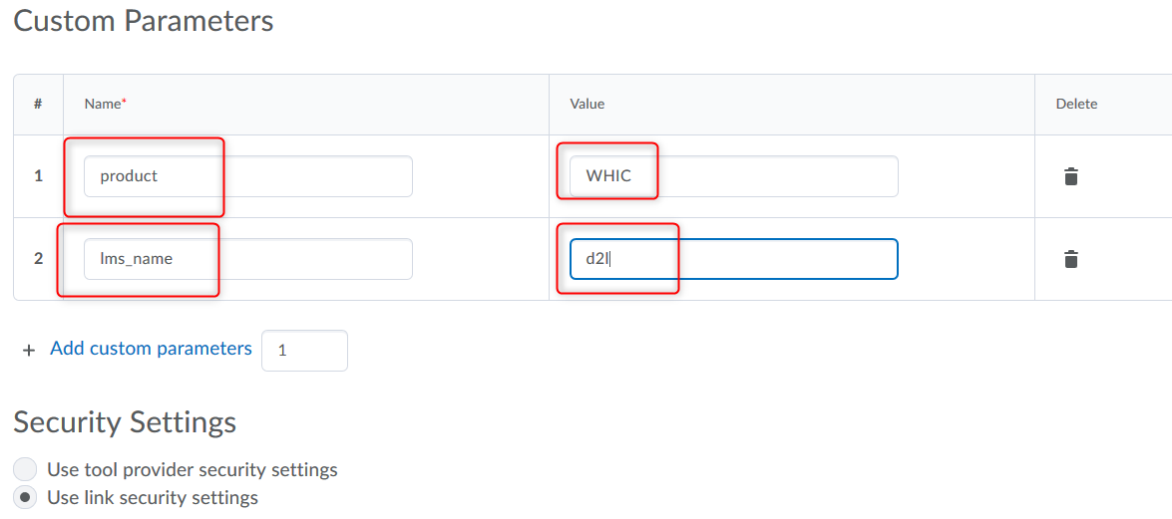

- Keep the default settings for Security Settings
- Put a checkmark next to the courses where you’d like to have the link available
- Click Save and Close

