January 2021
Canvas Installation Guide

Within a course, click the Settings link at the bottom of the course navigation.

Click the Apps tab.

Click the View App Configurations button.

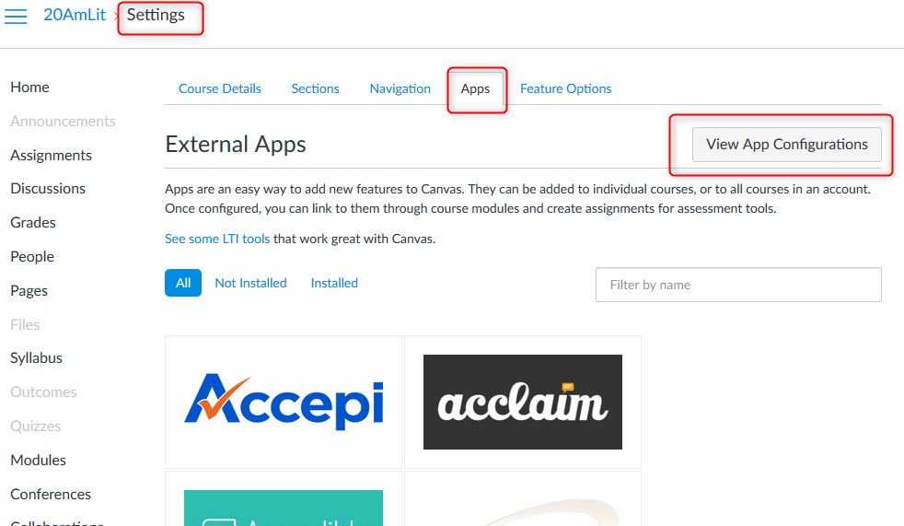

Click the +App button.

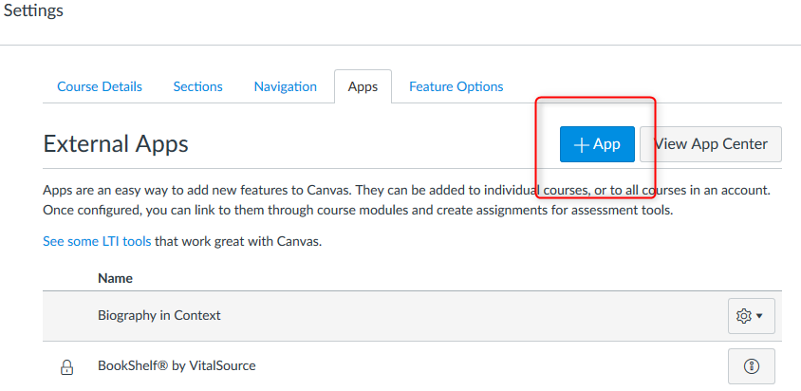

On the Add App form:
- Select By URL configuration type

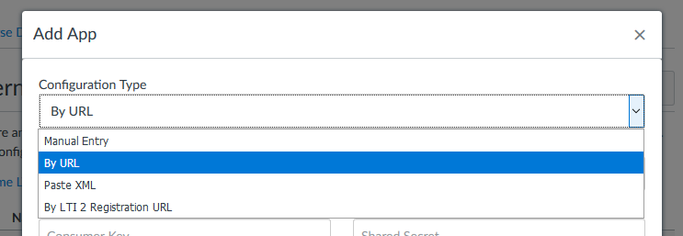

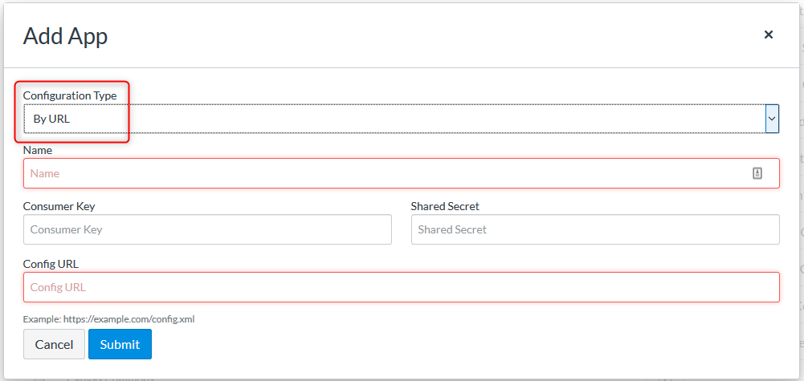

- Enter a Name (e.g. Gale In Context: Opposing Viewpoints, GVRL eBooks, Gale Primary Sources)
- Enter the Consumer Key (contact your Gale Customer Success Manager if you don't know yours)
- Enter the Secret into the Shared Secret field (contact your Gale Customer Success Manager to generate for you)
- Paste the appropriate URL into the Config URL field (configuration URLs are available via your Customer Success Manager or see LTI Install URLs document at https://support.gale.com/technical/lms)

For example, Gale Academic OneFile: https://link.gale.com/apps/configuration.xml?product=AONE&lms=canvas

Click Submit

By default, the App will appear in the Editor Button, and will be hidden in the course navigation.

To add the App to the course navigation, first click into Placements

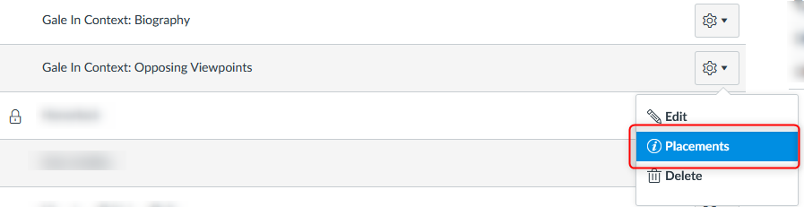

Then click the “x” next to Navigation to make it Active with a green checkmark.
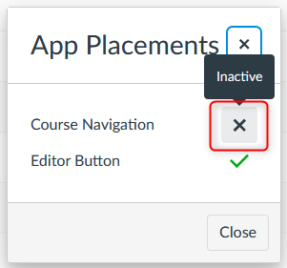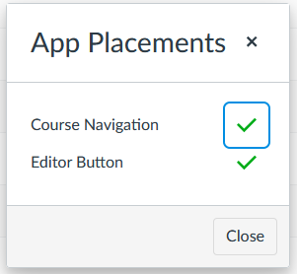

Click Close and then go to the Navigation tab to Drag the App up so that it appears in the course navigation.

