July 2020
Blackboard Installation Guide

*Note: You’ll need to install each App/Product separately, changing the name and custom parameters for installation.

From within the Courses tab select the course where you’d like to add the Gale resource.

Select Content from the left navigation, then Build Content, then Web Link.
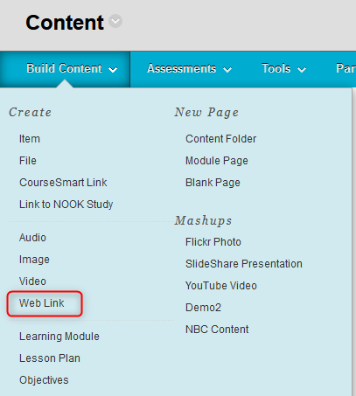

Fill in the information for creating a new Web Link, clicking the box next to “This Link is to a Tool Provider”

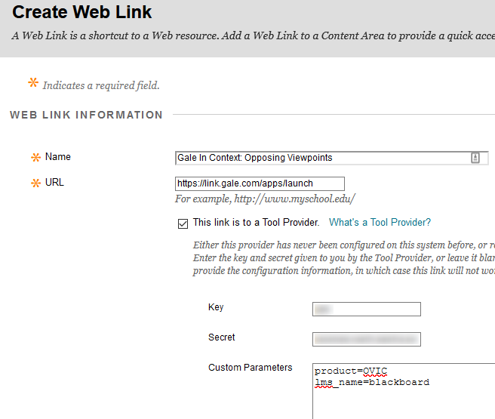

Name: Gale resource name
URL: launch URL https://link.gale.com/apps/launch
Key = Contact your Gale Customer Success Manager if you don't know yours
Secret = Contact your Gale Customer Success Manager to generate for you
Custom Parameters: Parameters vary by product and are available at http://support.gale.com/technical/lms
Example:
product=OVIC
lms_name=blackboard

You have the option to add a Description and determine whether the resource opens in a new browser window or within the Blackboard frame (Open in New Window).

Click Submit

The resource now appears under Content in the course.
