Gale’s Student Resources In Context
Social Media Posts
Primary Audience: Students
Secondary Audience: Teachers and Parents

How to Use: (1) Copy and paste the description into your Facebook or Twitter page. (2) Include a social media image with each post. (3) Link to your Student Resources In Context product page. You can shorten the link with bit.ly.

How to Display:
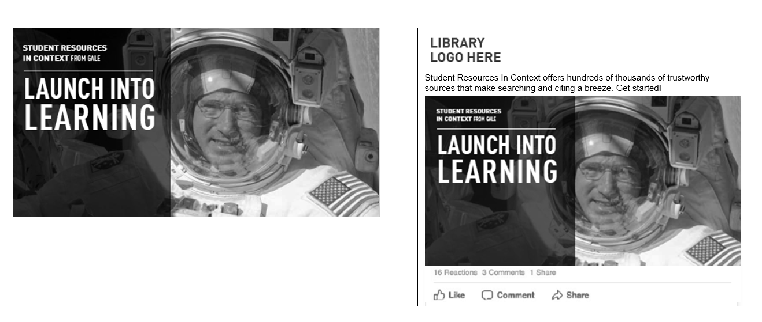

 | POST COPY/TEXT | Facebook | Twitter*
1 | LAUNCH INTO LEARNING  Student Resources In Context offers hundreds of thousands of trustworthy sources that make searching and citing a breeze. Get started! <link to access> | Yes | Yes  w/o headline
2 | APPROACH RESEARCH LIKE A PRO  Want to find credible content on core subjects and reduce your research time? Get started with Student Resources In Context! <link to access> | Yes | Yes  w/o headline
3 | Student Resources In Context lets you easily navigate through hundreds of thousands of images, videos, and audio selections. Access now! <link to access> | Yes | Yes
4 | With Student Resources In Context, you’ll never have to wonder if your sources are credible. Plus, citations are formatted for you and ready to turn in! Access at <link to access> | Yes | Yes
5 | Become a learner and a thinker. Student Resources In Context gives deeper context to the high-interest topics you’re studying. Access at <link to access> | Yes | Yes

*As of November 2017, tweet character counts have risen from 140 to 280, although readership is higher if tweets stay short.

