Gale In Context: Elementary
Blog Post
Primary Audience: Parents
Secondary Audience: Teachers

How to Use: (1) Customize the copy as needed. (2) Hyperlink to your library’s website or Gale In Context: Elementary product page. Shorten the link with Bitly, if needed. (3) Copy and paste the copy into your blog. (4) Proof and ensure the hyperlink works. (5) Post.

Discover How Your Child Can Be Inspired to Learn
Did you know penguins can’t fly but they are excellent swimmers? Your grade-schooler can learn about these flightless friends and so much more with Gale In Context: Elementary. Offered through your child’s school library, this simple-to-use digital resource helps grade-schoolers become comfortable researching. With Gale In Context: Elementary, kids have easier access to K-5 content—all in one place! This encourages them to move at their own pace through periodicals, videos, and more to find information on a wide range of topics with kid-friendly visuals and prompts.
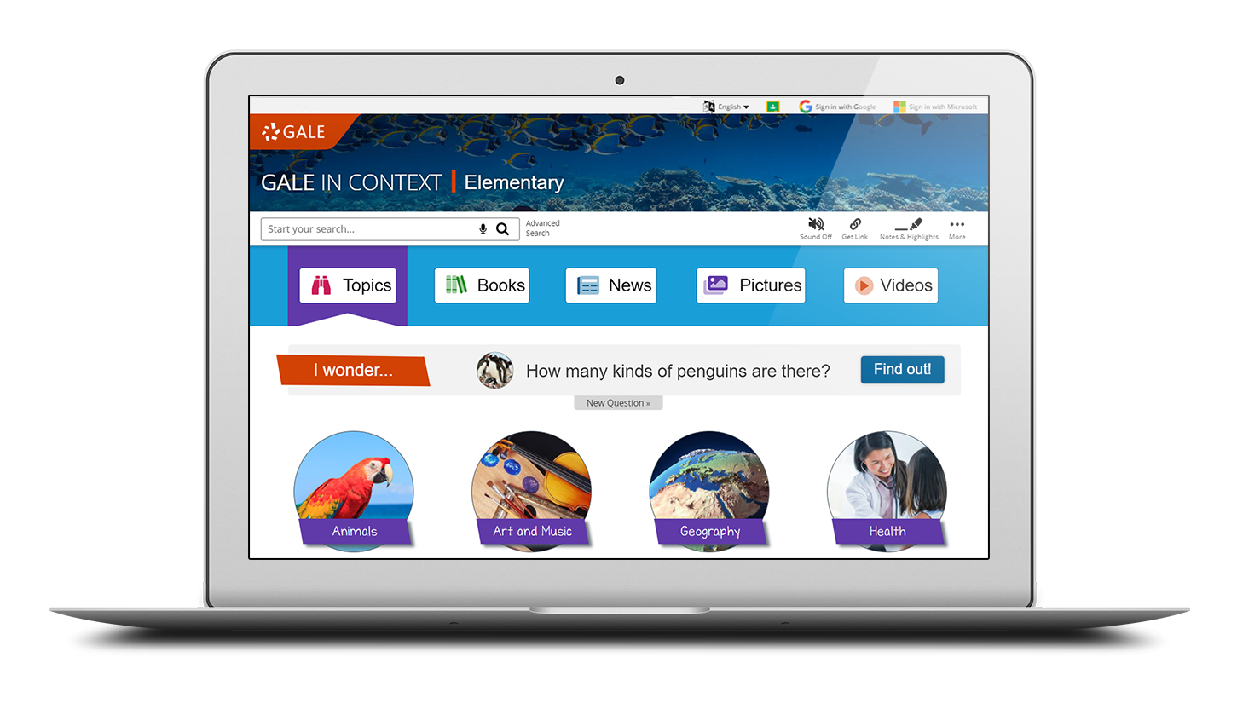
Among the many features designed to engage young learners, it includes a topic tree, “I Wonder . . .” questions, and fun facts to prompt students to choose topics that appeal to them. The “I Wonder . . .” question is updated daily and located on the home page to encourage engagement and inquisitiveness.

Additionally, kids can access eBooks right inside Gale In Context: Elementary. This connects them directly to their K-5 eBooks from Gale—providing uninterrupted access to all elementary school content within one platform.

Want to explore other fun factoids with your child? Access Gale In Context: Elementary now at <hyperlink to your library’s website or Gale In Context: Elementary product page>. Ask me if you need the username and password and/or additional help getting started.

<Librarian’s Name>
<Title>
<School>

