Always include your library’s web page with information on how to access Gale Interactive: Science or the Gale Interactive: Science access page itself. Shorten links with bit.ly, if needed.

Introducing Gale Interactive: Science: Make Science Come “Alive”

“Equipped with his five senses, man explores the universe around him and calls the adventure ‘science.’” – Edwin Powell Hubble

Famed astronomer Hubble articulated simply what great science teachers have always known: science is based on exploration, interaction, and engagement. When students connect with concepts in a meaningful, tactile way, they learn in a more meaningful way.
That belief is the foundation of Gale Interactive: Science, a new resource with interactive 3-D models and authoritative, curriculum-aligned digital content that helps students experience science, not just study it.

Designed to supplement science course materials in a fresh, unprecedented way, the resource is brimming with relevant images that can be rotated, magnified, and closely examined to enhance experiential learning. Students can explore on their own to assist with homework and research assignments, or teachers can use the online resource in the classroom to demonstrate concepts and expand discussion. Content supports the study of biology, chemistry, and earth sciences – making it an ideal resource for high school students.
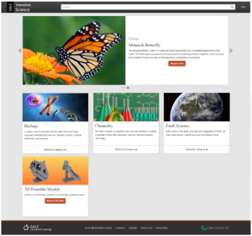

For example, when studying insects, students can find images of specific insect types which can be manipulated to allow different views. It’s like examining each bug in person – but possibly even more useful, as unique features can be explored by zooming in. And with different resources available, such imagery as cross-sections and other scientific views are available to support in-depth investigation.
Gale Interactive: Science features special content and functionality that support learning, such as:
- Self-quizzing capabilities at the end of every session to review key concepts.
- Guided interactive lessons, as well as “anytime” student/faculty interaction with models.
- Ease of use on computers, laptops, interactive whiteboards, or a projector.
- Accessible through multiple browsers – Chrome, Firefox, Safari, and MS Edge.
- Authoritative content from resources such as Gale’s Science In Context, Grzimek’s Student, Academic OneFile, and more.
- 3-D printing with installed driver and an optional 3-D printer to print teaching models for use directly in the classroom.
- Interface and content available in multiple languages.

With a resource like this, science will become a fun, exciting subject. Gale Interactive: Science takes the struggle out of science and it is at your fingertips 24/7. Take it for a test drive and see for yourself at <LINK TO ACCESS> or for more information, contact <CONTACT INFORMATION>.

