Social Media Posts
Always include your library’s web page with information on how to access ChiltonLibrary or the ChiltonLibrary access page itself. Shorten links with bit.ly, if needed.
 | POST COPY/TEXT | Facebook | Twitter
1 | April is National Car Care Month, what are you doing to show your vehicle some love? Look to ChiltonLibrary found on our website for your car’s maintenance intervals and service bulletins. <link to access> | Yes | No
2 | Car Trivia: In what year did the steering wheel replace the steering tiller? ChiltonLibrary can provide you with more insight on your steering wheel today if you’re having problems. <link to access>  Comment with answer: 1898 | Yes | No
3 | Turn to ChiltonLibrary for the most reliable, up-to-date car repair guidance. Get the latest recall info too! <link to access> | Yes | Yes
4 | ChiltonLibrary is your one-stop source for car repair information covering most makes, models and years. <link to access> | Yes | Yes
5 | Add hair conditioner (with lanolin) to your soap and your car will shine and repel rain! Visit ChiltonLibrary, found on our website, the most trusted name in car repair. <link to access> | Yes | No
6 | Car Care Tip of the Day: Park your car facing east to defrost the windows in the morning. <link to access> | Yes | Yes
7 | Car Care Tip of the Day: A plunger will remove small dents. <link to access> | Yes | Yes
8 | Car Care Tip of the Day: Use wet newspaper to removes stubborn stickers on car windows. <link to access> | Yes | Yes
9 | Car Care Tip of the Day: The more keys on your chain, the more quickly your ignition lock/switch will fail. <link to access> | Yes | Yes
10 | Car Care Tip of the Day: Place a dryer sheet in your cabin filter to freshen your circulating air. <link to access> | Yes | Yes
11 | Car Care Tip of the Day: Putting your key fob to your chin will increase its range. <link to access> | Yes | Yes
12 | Car Care Tip of the Day: Prevent someone from stealing your registration sticker by cross-cutting it with a razor blade. <link to access> | Yes | Yes
13 | Car Care Tip of the Day: Toothpaste will clean foggy headlights and paint scuffs. <link to access> | Yes | Yes
14 | Car Care Tip of the Day: Hanging a tennis ball from your garage ceiling can help prevent parking to close to the garage wall. <link to access> | Yes | Yes
15 | Car Care Tip of the Day: 10 seconds of idling wastes more fuel that restarting your engine. <link to access> | Yes | Yes
16 | Did you know you can get comprehensive, dynamic online auto repair support 24/7 at your library with ChiltonLibrary?! <link to access> | Yes | Yes
17 | Access to authoritative, money-saving auto repair guides here today! <link to access> | Yes | Yes
28 | Did you know you can get 24/7 access to Chilton’s money saving online auto repair manuals from any computer, phone or tablet?! <link to access> | Yes | Yes
19 | Did you know audio content from the Repair section in ChiltonLibrary can be downloaded in MP3 format to save and access offline? Check it out here: <link to access> | Yes | No
20 | ChiltonLibrary’s dynamic search engine helps users find specific procedures quickly and offers other benefits. <link to access> | Yes | Yes
21 | We have domestic and import vehicle information through the current model year, updated continuously by ChiltonLibrary. <link to access> | Yes | Yes
22 | Is your car in need of auto repairs? Access step-by-step instructions and videos from Chilton. <link to access> | Yes | Yes
23 | Auto repair, maintenance, labor estimating, and bulletin/recall information is available through Chilton. <link to access> | Yes | Yes
24 | Be pothole prepared with suspension, steering, tires, wheels & alignment data from ChiltonLibrary! ‬‬‬<link to access>‬‬‬‬‬ | Yes | Yes
25 | Need a little help fixing your car? Access step-by-step instructions and videos from Chilton. <link to access> | Yes | Yes
26 | Does your car make a funny noise? Checking service and recall bulletins can save time, money and frustration. That’s where ChiltonLibrary can help! <link to access> | Yes | No

Picture 4
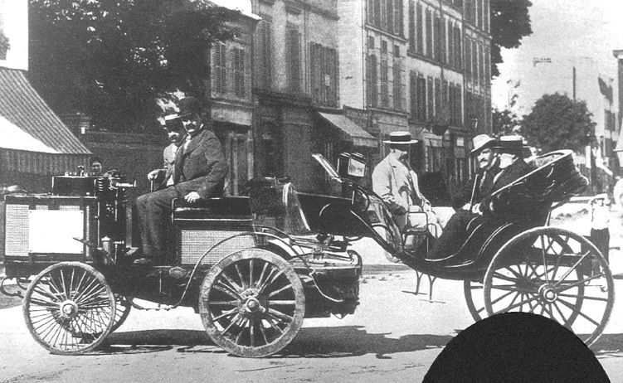

Picture 5
Picture 6
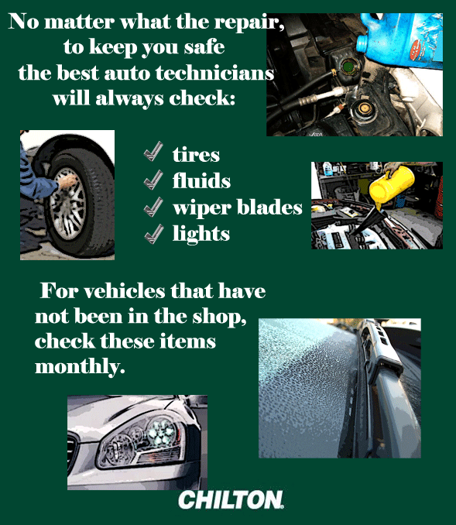

Picture 7
Picture 9
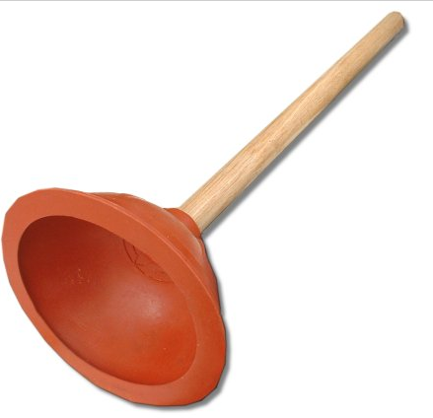
Picture 11
Picture 15
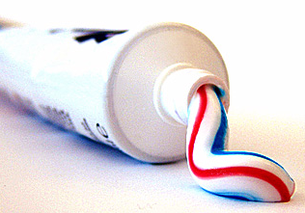

Picture 18:
