Always include your library’s web page with information on how to access ChiltonLibrary or the access page itself. Shorten links with bit.ly, if needed.
Turbochargers – Pump It Up
By: Jim Marotta; Originally posted on blog.gale.com
At 100 horsepower per liter, GM’s newer turbocharged 1.4L has the power of a larger engine but retains the efficiency of a small-displacement four-cylinder in most driving conditions. Courtesy GM

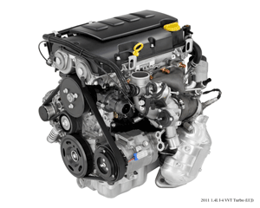

A naturally aspirated automobile engine uses the downward stroke of a piston to create an area of low pressure in order to draw air into the cylinder through the intake valves. Because the pressure in the atmosphere is no more than 14.7 psi, there is a limit to the amount of airflow entering the combustion chamber.
A turbocharged engine uses a radial fan pump driven by the engine’s exhaust that consists of a turbine and a compressor on a shared shaft. The turbine converts exhaust gases exiting the engine into rotational force, which is used to drive a compressor which draws in ambient air and pumps it at high pressure into the intake manifold to improve the engine’s volumetric efficiency. This results in a greater mass of air entering the cylinders on each intake stroke.
There are four main components to a turbocharger: the housing, the impeller/turbine wheels, the center hub and the bypass.
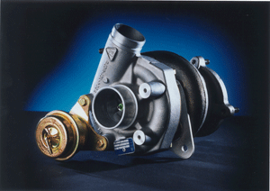
The size and shape of the housings fitted around the impeller and turbine affect performance, response, and efficiency. Courtesy Borg-Warner
The size and shape of the housings fitted around the impeller and turbine dictate the performance characteristics of the overall turbocharger. This allows the designer of the engine system to tailor the compromises between performance, response, and efficiency to application or preference.
The impeller and turbine wheel sizes also dictate the amount of air or exhaust that can be flowed through the system. Generally, the larger the turbine and compressor wheels, the larger the flow capacity. The shape, curvature and number of blades on the wheels allow infinite variability in design to tailor a turbocharger to a given engine.
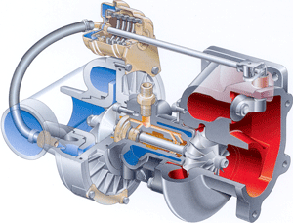
Water-cooled bearings, such as the one shown, allow engine coolant to keep the lubricating oil cooler, avoiding possible oil coking from the extreme heat found in the turbine. Courtesy Borg-Warner
The center hub connects the compressor impeller and turbine and uses a bearing lubricated by a constant supply of pressurized engine oil. While the engine oil cools some systems, the preferred method is to use engine coolant to keep the lubricating oil cooler, avoiding possible oil coking from the extreme heat found in the turbine.
Turbos use a bypass or wastegate to prevent over-pressurizing the system. At a specific boost pressure, a bypass feeds part of the exhaust gas flow around the turbine. The wastegate which opens or closes the bypass is usually operated by a spring-loaded diaphragm in response to the boost pressure.
There are several tips to maintaining and servicing turbochargers:
- Engineers design turbochargers to last the lifetime of the engine. They normally do not require any special maintenance; however observe strict adherence to the engine manufacturer’s service instructions. Ninety percent of all turbocharger failures are due to either foreign bodies entering into the turbine or the compressor, dirt in the oil, inadequate oil supply, or high exhaust gas temperatures.
- The most important maintenance factor is clean oil. Since turbochargers can be easily damaged by dirty or ineffective oil, most manufacturers recommend more frequent oil changes for turbocharged engines. The use of synthetic oils, which tend to flow more readily when cold and do not break down as quickly as conventional oils, is also a common practice.
- Since the turbocharger generates heat when running, many automakers recommend letting the engine idle before shutting off the engine if the turbocharger was used shortly before stopping. Most manufacturers specify a 10-second period of idling before switching off, for a couple of reasons: (1) to ensure the turbocharger is running at its idle speed, and (2) to prevent damage to the bearings when the oil supply is cut off. Idling lets the turbo rotating assembly cool from the lower exhaust gas temperatures, and ensures that oil is supplied to the turbocharger while the turbine housing and exhaust manifold are still very hot; otherwise coking of the lubricating oil trapped in the unit may occur when the heat soaks into the bearings, causing rapid bearing wear and failure when the car is restarted. Even small particles of burnt oil will accumulate, lead to choking the oil supply, and failure.
- The easiest way to diagnose a weak turbocharger is to observe the turbo boost. If the turbocharger does not show normal boost at full throttle (typically 9 to 14 psi), the system needs further diagnosis. One common but overlooked condition is excessive exhaust backpressure (often due to a clogged catalytic converter) which can prevent the turbo from developing its normal boost pressure.
Planning to service or repair your vehicle? ChiltonLibrary can help! We have all the information car owners need to understand, diagnose and solve vehicle problems and make informed decisions. <INSERT LINK TO ACCESS>

